**Image Processing System – Low-Level Design Document**

**1. Overview**

The Image Processing System is designed to process CSV uploads that contain product information and image URLs. Upon receiving a CSV file, the system validates the file, downloads and compresses the images asynchronously, stores a processed CSV, and inserts processed data into a PostgreSQL database. Clients can query the processing status via a status API. The system is built using Python, asyncio for concurrency, and PostgreSQL for persistent storage.

## 2. System Architecture & Components

### 2.1 High-Level Architecture Diagram

Below is a simplified diagram (conceptual view) of the system architecture:

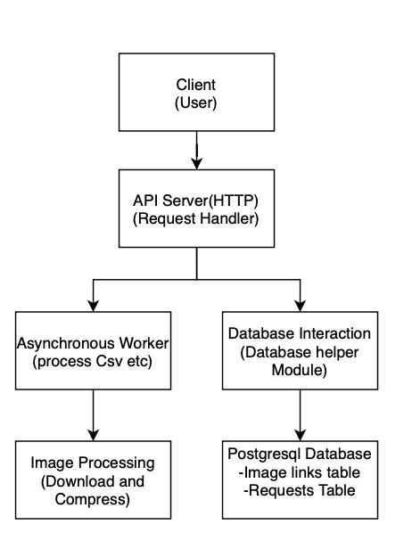

### 2.2 Component Descriptions

* **API Server (HTTP Endpoints):**
  + **Upload API (/upload):** Accepts multipart/form-data CSV file uploads, performs preliminary CSV validation, and returns a unique request ID along with processing results (success/failure counts).
  + **Status API (/status/{request_id}):** Allows clients to check the processing status of a request using the unique request ID.
* **Asynchronous Worker (Image Processing Service):**
  + Uses asynchronous tasks (via asyncio) to download and compress images concurrently.
  + Reads the CSV file, validates required fields, downloads images from URLs using the requests module, compresses images with Pillow (PIL), and saves the processed image URLs.
  + Creates a processed CSV file stored in a designated static directory.
  + Inserts each processed row into the public.image_links table in the database.
* **Database Interaction:**
  + **DatabaseHelper Module:** Centralizes all database operations (e.g., saving request, updating status, inserting image links, deleting a request).
  + Utilizes psycopg2 for PostgreSQL connectivity.
  + Two main tables:
    - requests: Tracks each processing request and its status.
    - public.image_links: Stores product details and associated image URLs after processing.

## 3. Database Schema

### 3.1 requests Table

* **Columns:**
  + id (text, primary key): Unique request identifier.
  + status (text): Current processing status (e.g., “processing”, “completed”).

### 3.2 public.image_links Table

* **Columns:**
  + id (serial, primary key)
  + request_id (text): References the requests table (with cascade deletion).
  + serial_number (integer): Product serial number.
  + product_name (text): Name of the product.
  + input_image_urls (text): Original image URLs from the CSV.
  + output_image_urls (text): Processed/compressed image URLs.

## 4. API Documentation

### 4.1 Upload API

* **Endpoint:** POST /upload
* **Content-Type:** multipart/form-data
* **Description:**  
  Accepts a CSV file upload containing columns "Serial Number", "Product Name", and "Input Image Urls". Validates the CSV, returns an error if invalid, or proceeds to process the file asynchronously.
* **Response:**
  + **200 OK:** All rows processed successfully.
  + **206 Partial Content:** Some rows processed successfully while others failed.
  + **400 Bad Request:** CSV validation failed or no successful rows.
* **Response Body Example:**

{

"request_id": "a1b2c3d4-e5f6-7890-abcd-ef1234567890",

"success_count": 10,

"failure_count": 2

}

* **Note: In case of all invalid image urls, it will show bad request but the request will be processed since the data is not invalid.**

### 4.2 Status API

* **Endpoint:** GET /status/{request_id}
* **Description:**  
  Retrieves the current status of a processing request.
* **Response:**
  + **200 OK:** Returns the status of the request.
* **Response Body Example:**

{

"status": "completed"

}

Can show status as completed, processing or not found depending on status id.

**5. Asynchronous Workers Documentation**

* **Function:** process_csv(csv_content, request_id, validate_only=False)
  + **Purpose:**  
    Validates CSV content, downloads images, compresses images asynchronously, writes a processed CSV file, and inserts each valid row into the database.
  + **Workflow:**
    1. **Validation:** Reads CSV rows and checks for required fields.
    2. **Task Scheduling:** For valid rows, schedules asynchronous image download and compression tasks.
    3. **CSV Output:** Writes the processed data (including processed image URLs) to a new CSV file.
    4. **Database Insertion:** Inserts processed row data into public.image_links using insert_image_link.
    5. **Status Update:** Once complete, updates the request status to "completed".
  + **Error Handling:**  
    Catches exceptions during processing, logs errors, and if needed, cleans up any temporary files.
* **Function:** download_and_compress(url, request_id, index)
  + **Purpose:**  
    Downloads the image from the provided URL, compresses it using JPEG quality settings, and stores it in a request-specific folder.
  + **Returns:**  
    The relative URL path if successful or "error" if any issue occurs.

**6. GitHub Repository**

**Link:** [**https://github.com/kanishk-ramrakhiyani/Image-Processing**](https://github.com/kanishk-ramrakhiyani/Image-Processing)

**7. Postman Collection**

**Link:** [**https://www.postman.com/maintenance-engineer-22657487/workspace/image-processing/collection/36634943-9099507d-1f6e-4006-a43d-facd50f55b27?action=share&creator=36634943**](https://www.postman.com/maintenance-engineer-22657487/workspace/image-processing/collection/36634943-9099507d-1f6e-4006-a43d-facd50f55b27?action=share&creator=36634943)